Module Name: ADVANCED ARTIFICIAL INTELLIGENCE PROJECTS IN DATA SCIENCE
Module Code: 55-710603
Multimodal Emotion Recognition from Facial Expressions and Speech Signals Using Fusion Networks
Student Name and ID: Rajagopala Rao Bandaru (35050526)

Table of Contents
Part A: Introduction 3
Part B: Technical Review 3
Part C: Design & Implementation 3
Methodology 3
Data Pipeline 3
Feature Extraction and Analysis 3
Multimodal Integration and Implementation 4
Part D: Technical & Critical Evaluation 4
Technical Evaluation 4
Comparative Analysis 4
Critical and Social Evaluation 4
Part E: Project Proposal & Management 5
Project Management Review 5
Future Work Proposal 5
Part F: Conclusion 5
References 6
Appendix 7

Part A: Introduction
Emotion recognition is an essential component of human interaction and smart human-machine interactions (Houssein, Hammad and Ali, 2022). As AI technology advances in health care, education and personal assistants, emotion recognition is vital. But existing systems are based on a single modality (e.g. facial or speech), which can be inaccurate. Facial expression recognition systems suffer from lighting variations, occlusions, and low-resolution cameras (Khan et al., 2024), and speech-based systems can be influenced by accents, background noise, and recording quality. To address these issues, this project will develop a multimodal emotion recognition system that integrates facial and speech information, leveraging deep learning and fusion strategies (Lian et al., 2023). It recognises six emotions - happy, sad, angry, fear, surprise and neutral - with a goal of achieving higher accuracy than single-modality systems, around 85%. The project also meets several learning outcomes, such as applying AI techniques, designing solutions, assessing performance, and considering ethical issues.

Part B: Technical Review
The project combines several areas of AI including deep learning, computer vision, speech, and multimodal learning. CNNs are applied to learn spatial features of faces (Mohiddin, Sharmila and Slimani, 2026), and LSTMs are used to learn temporal features of speech (Mienye and Swart, 2024). Facial emotion recognition includes preprocessing techniques such as normalization and augmentation, but is affected by environmental factors (Hasanat et al., 2025). In speech emotion recognition, MFCC features are used to represent speech, but are susceptible to noise and variability (Wang, Saleem and Gunawan, 2024). Multimodal learning integrates both modalities through early and late fusion approaches, enhancing robustness and accuracy. But issues such as processing time, synchronisation, and integration need to be addressed (Barua, Ahmed and Begum, 2023).

Part C: Design & Implementation

Methodology
The project adopts a structured, data-driven approach to create a multimodal emotion recognition system that integrates facial emotion recognition and speech recognition systems. The process involves data collection, data preprocessing, model training, multimodal data fusion and evaluation (Refer Appendix Figure.1). Facial expressions are rescaled, and audio signals are transformed to numerical features via MFCCs. It involves training two deep learning networks, a CNN for facial emotion recognition and LSTM for speech emotion recognition. These are then combined using early (feature-level) and late (decision-level) fusion. The system is evaluated using metrics such as accuracy, precision, recall and F1-score, while maintaining a modular and optimised system design.

Data Pipeline
The FER2013 dataset and RAVDESS dataset are used for facial and speech recognition, respectively. Data preprocessing ensures uniformity through resizing, greyscaling, normalisation and augmentation. The audio data is processed with MFCC, denoising, padding, and scaling (Refer Appendix Figure.2). Waveforms, Mel-spectrograms, and MFCCs are visualised for patterns of emotions, and augmentation (noise, time shifting) is applied for embedding (Refer Appendix Figure.3).
Dataset1 link:https://www.kaggle.com/datasets/uwrfkaggler/ravdess-facial-landmark-tracking
Dataset2 link:https://www.kaggle.com/datasets/uwrfkaggler/ravdess-emotional-speech-audio

Feature Extraction and Analysis
Facial features like Action Units, head pose, and gaze are visualised and converted into statistical features for classification (Refer Appendix Figure.4). Convolutional Neural Networks (CNNs) represent spatial features for facial expressions, and Long Short-Term Memory (LSTMs) model temporal speech features. Radar charts display different Action Unit patterns for emotions, confirming feature validity (Refer Appendix Figure.5). t-SNE visualisation shows better clustering for facial features (Refer Appendix Figure.6), while MFCCs show overlapping clusters due to lower speech model accuracy (Refer Appendix Figure.7). EDA shows equal class distribution, high feature correlation (Refer Appendix Figure.8).

Multimodal Integration and Implementation
Multimodal integration involves the integration of both models through feature-level fusion, which enhances the prediction accuracy by utilising the strengths of both models. The system design includes using a fusion layer that combines outputs from CNN and LSTM to classify the data. The system is implemented in Python with TensorFlow, PyTorch, Scikit-learn, OpenCV and Librosa. Learning is achieved via categorical cross-entropy loss and Adam optimizer, mini-batch training, validation and early stopping. Generalisation is enhanced with hyperparameter optimisation and dropout. Despite issues like computational resource constraints and integration challenges, Google Colab and modular architectures allow for scalability and efficiency.

Part D: Technical & Critical Evaluation

Technical Evaluation
The facial emotion model uses structured (CSV-based) features, producing 2452 samples, 253 features across eight emotion classes. While balanced, there is minor class imbalance in disgust, surprised, and neutral (Refer Appendix Figure.9). The Extra Trees model performs well, making correct predictions with a high confidence (Refer Appendix Figure.10). It performs better than Random Forest (88.04%) and XGBoost (87.79%) with 89.82% validation accuracy and 90.02% test accuracy. High precision and recall values are observed in the classification, particularly for happy (F1: 0.97) and calm (F1: 0.95), but surprised (F1: 0.69) has lower values because of low sample numbers (Refer Appendix Figure.11 and 12). Speech emotion recognition model is trained on the RAVDESS dataset, 2880 samples are converted into MFCC features. It is divided into training, validation and test sets (Refer Appendix Figure.13). Exploratory Data Analysis indicates balanced data and uniform duration, with varying signal levels across emotions (Refer Appendix Figure.14). Training accuracy of 96.9% and low validation accuracy (51-53%) suggests overfitting (Refer Appendix Figure.15). Test accuracy is poor (~36%, F1: 0.37) with similar emotions confusing (Refer Appendix Figure.16). Confidence and uncertainty in prediction is lower than facial model (Refer Appendix Figure.17 & 18).

Comparative Analysis
The results of the experiment are clear in demonstrating that the facial emotion recognition model is far superior when compared to the speech model. Compared to the facial model, which had about 90% accuracy, the speech model had a 36% accuracy. This implies that facial features are more dependable in this application. Nevertheless, the speech data continues to give supplementary emotional clues. Thus, multimodal fusion integrating both modalities may be a way to enhance system overall performance and robustness. Data tested to the trained models using UI and shown in the figure (Figure.19 Appendix).

Critical and Social Evaluation
The project has outstanding technical performance particularly in facial emotion recognition model, although various ethical and social concerns have to be considered. One of the biggest issues is bias and unbiasedness since the data sets used are unequal in the number of classes and may not be heterogeneous in terms of age, ethnicity, cultural manifestation, etc., and thus may lead to biased forecasts. The other major concern is the issue of privacy since the emotional recognition systems deal with sensitive data such as facial images and speech that increase the risks attached to consent, data privacy and abuse of processes in regards to surveillance or monitoring. Besides, the speech model identifies the technical limitations, like overfitting and ineffective generalisation, that imply that it is challenging to address the variation of real-world conditions, such as noise and environmental conditions. The latter issues can be addressed through responsible AI practices, which include the use of a wide range of datasets, bias reduction efforts and explainable AI. The deployment should be ethical and users must be informed and agree to it.

Part E: Project Proposal & Management

Project Management Review
The project was managed in a structured and collaborative manner with all the team members well identified and assigned specific roles and responsibilities as stated in the project charter. The secret was in GitHub that ensured a regular flow of progress was maintained and that there was a continuous flow of contributions and version control and transparency in development. The weekly reminders of the assignments and tasks helped to attain the significant milestones, i.e. data collection, the model development, and assessment.
The project was successful in a number of ways. The team has managed to apply the models of emotion recognition both in faces and speech and has been able to implement them in a modular format. The gradual improvement of the development process was assisted by the information flow and interaction of team members (Figure.19 Appendix).
However, the project had some serious obstacles as well. Among the largest problems was that multimodal capabilities had to be included, as the fact that there was one-to-one correspondence between speech and facial data suggested that more preprocessing and design issues had to be taken into account. Training efficiency was impacted by the computational limits (especially, the GPUs limits). The datasets were also skewed and this impacted the performance of the models, especially the speech model. These challenges were overcome through data augmentation, modular system design and use of cloud-based systems such as Google Colab.

Future Work Proposal
There are many ways in which the project can be expanded to improve performance and practical uses. To further enhance multimodal fusion of the features, first, more advanced deep learning architectures such as Transformer-based models, as well as attention mechanisms, can be considered. Second, it has the potential to be used as a real-time program because webcams and microphones and offer the opportunity to recognize emotions in real-time.
This can further be improved by having a larger and more data to minimise the bias and enhance the generalisation. Work of speech models would be enhanced through the use of noise resistant audio processing techniques. In addition, explainable AI methods could be added to improve the trust and transparency in prediction.
In practice, the system is in a good position to be applied in areas such as mental health surveillance, intelligent education application and human-computer interface. The possible continuation of this study could be a scholarly investigation of multimodal learning, bias reduction, and AI systems in the real time.

Part F: Conclusion
This project had the capability to develop a multimodal emotion recognition system that will integrate facial expression recognition with the speech signal recognition by using deep learning. The findings have shown that facial model has been accurate and good in generalisation but the speech model has shown the issues of overfitting and data complexity. These studies have shown the importance of multimodal approaches in order to achieve robustness and reliability.
The project met technical objectives as well, yet provided a bit of valuable information regarding constraints and ethical considerations of emotion recognition systems. These issues as prejudice, confidentiality, and the reliability of the models were identified and analyzed, which presupposes that there should be responsible AI practices.
Altogether, this work contributes to the field of intelligence systems proving the usefulness of combination of various types of data. It provides a good foundation of future research and application in emotion-sensitive technologies.

References
Barua, A., Ahmed, M.U. and Begum, S. (2023) 'A Systematic literature review on Multimodal Machine learning: applications, challenges, gaps and future directions,' IEEE Access, 11, pp. 14804–14831. https://doi.org/10.1109/access.2023.3243854.
Hasanat, M.H.A. et al. (2025) 'Facial Recognition and Detection: Overcoming Pose Variations and Enhancing Accuracy with Machine Learning Implementation,' in Lecture notes in networks and systems, pp. 164–176. https://doi.org/10.1007/978-3-031-91005-0_16.
Houssein, E.H., Hammad, A. and Ali, A.A. (2022) 'Human emotion recognition from EEG-based brain–computer interface using machine learning: a comprehensive review,' Neural Computing and Applications, 34(15), pp. 12527–12557. https://doi.org/10.1007/s00521-022-07292-4.
Khan, U.A. et al. (2024) 'Exploring contactless techniques in multimodal emotion recognition: insights into diverse applications, challenges, solutions, and prospects,' Multimedia Systems, 30(3). https://doi.org/10.1007/s00530-024-01302-2.
Lian, H. et al. (2023) 'A survey of Deep Learning-Based multimodal emotion recognition: speech, text, and face,' Entropy, 25(10), p. 1440. https://doi.org/10.3390/e25101440.
Meena, G. et al. (2023) 'Identifying emotions from facial expressions using a deep convolutional neural network-based approach,' Multimedia Tools and Applications, 83(6), pp. 15711–15732. https://doi.org/10.1007/s11042-023-16174-3.
Mienye, I.D. and Swart, T.G. (2024) 'A comprehensive review of deep learning: architectures, recent advances, and applications,' Information, 15(12), p. 755. https://doi.org/10.3390/info15120755.
Mohiddin, S.K., Sharmila, S. and Slimani, K. (2026) 'Advanced techniques in facial landmark detection and feature extraction for Emotion-Aware AI systems,' in Information systems engineering and management, pp. 157–173. https://doi.org/10.1007/978-3-032-14778-3_8.
Wang, J., Saleem, N. and Gunawan, T.S. (2024) 'Towards efficient recurrent architectures: a deep LSTM neural network applied to speech enhancement and recognition,' Cognitive Computation, 16(3), pp. 1221–1236. https://doi.org/10.1007/s12559-024-10288-y.

Appendix

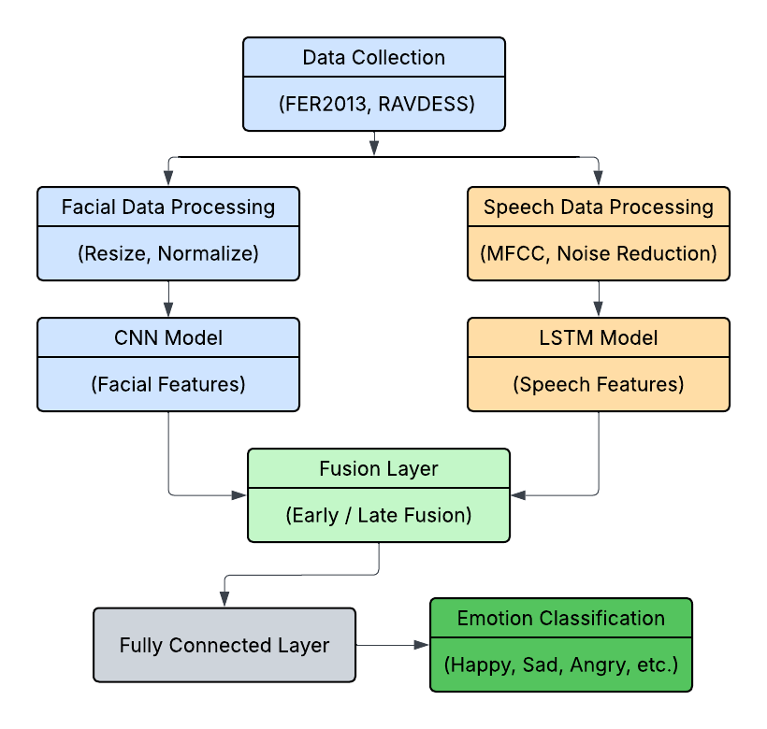
Figure 1 Block diagram of the proposed multimodal emotion recognition methodology

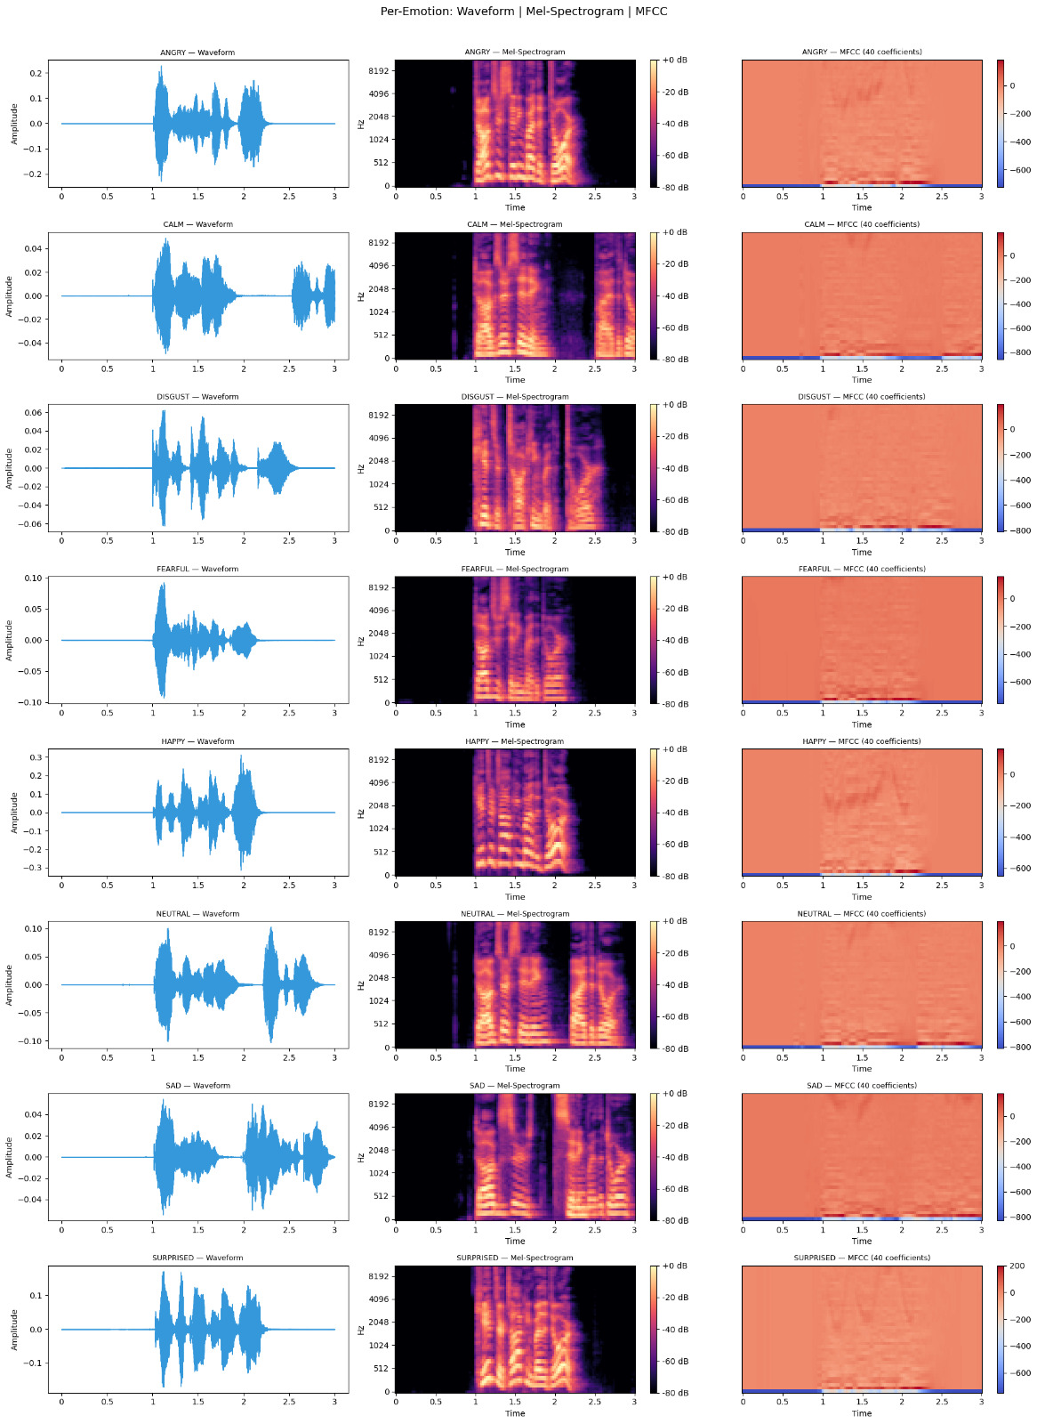
Figure 2 Visual representation of speech signals including waveform, Mel-spectrogram, and MFCC features across emotions

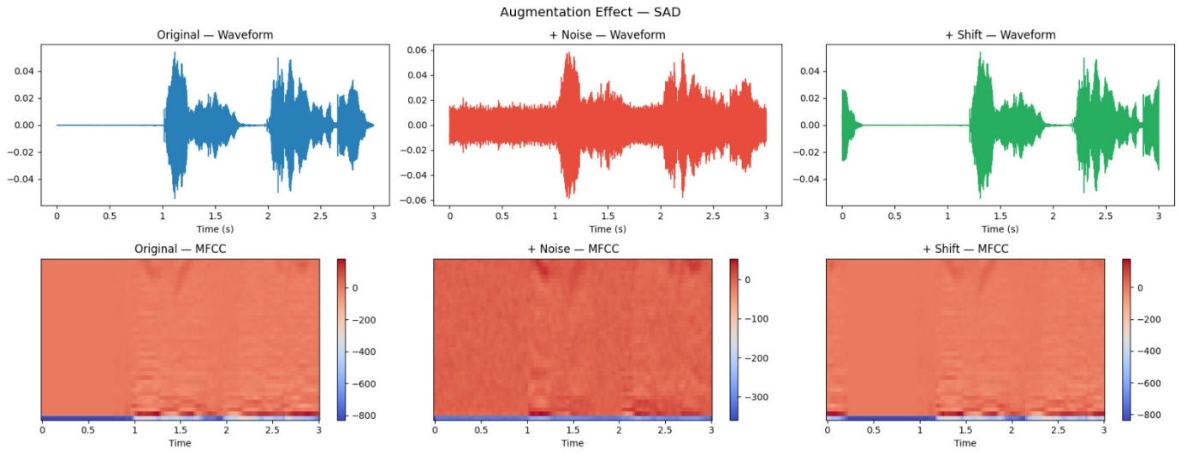
Figure 3 Effect of audio augmentation techniques including noise addition and signal shifting on waveform and MFCC features
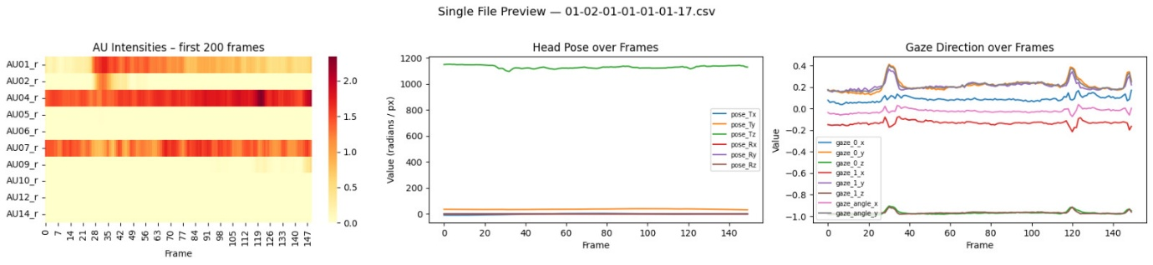
Figure 4 Sample facial feature signals including Action Units, head pose, and gaze direction over time
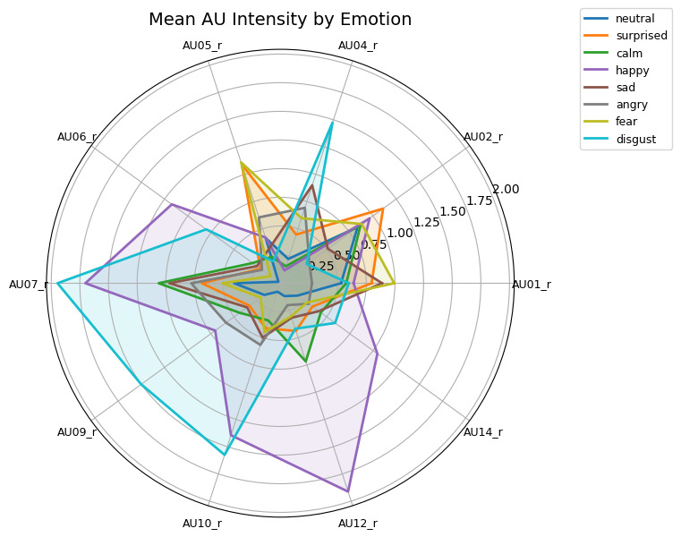
Figure 5 Sample facial feature signals including Action Units, head pose, and gaze direction over time

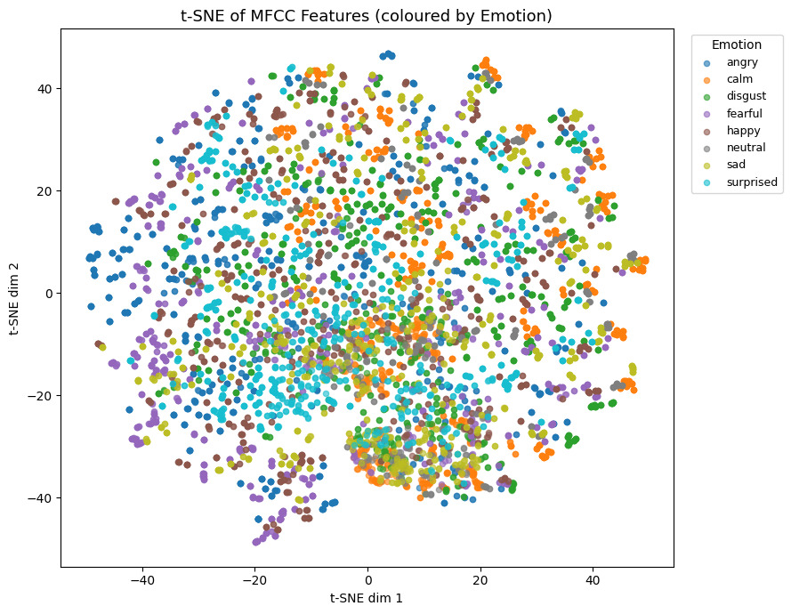
Figure 7 t-SNE visualization of MFCC features coloured by emotion

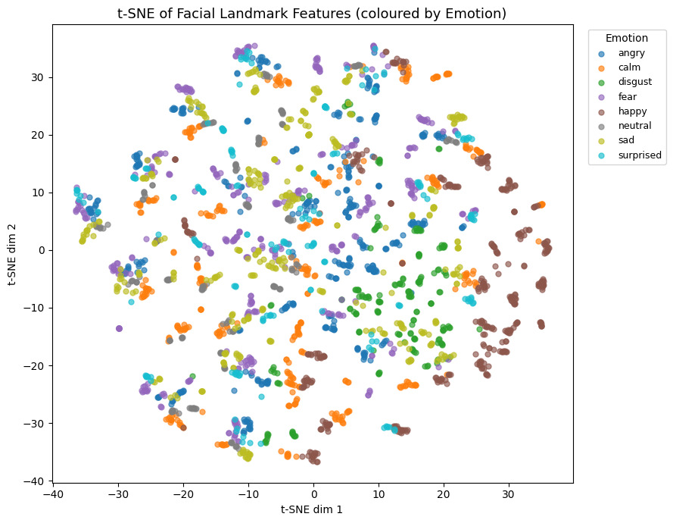
Figure 6 t-SNE visualization of facial landmark features coloured by emotion

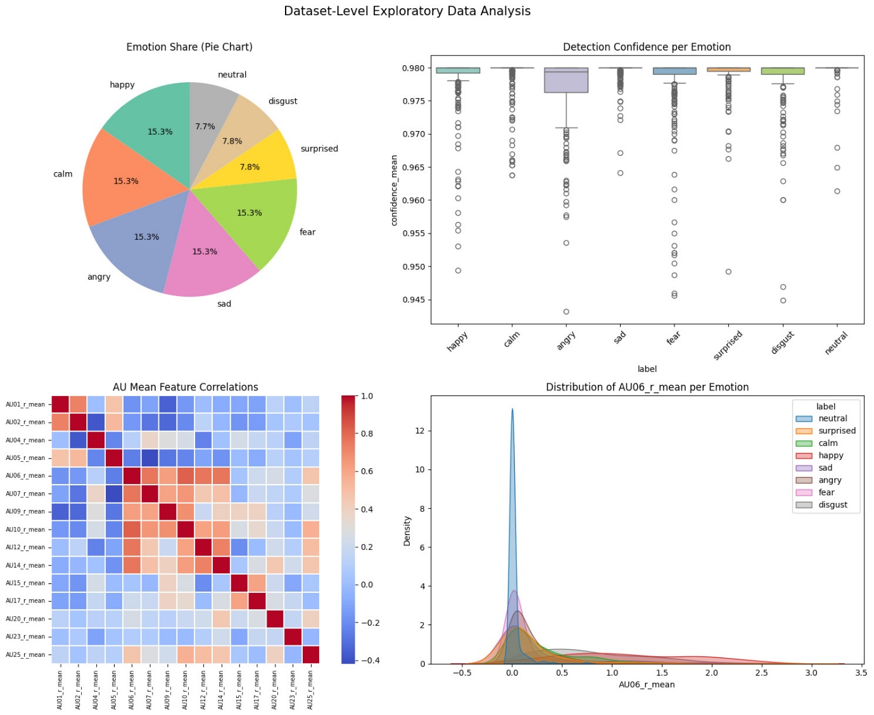
Figure 8 Dataset-level exploratory analysis of facial features including emotion distribution, detection confidence, feature correlations, and AU06 distribution
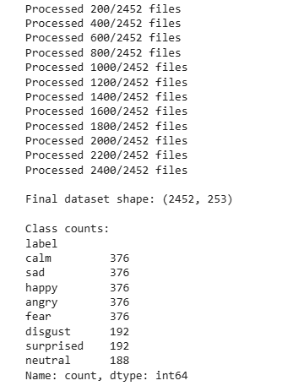
Figure 9 Emotion class distribution of facial dataset
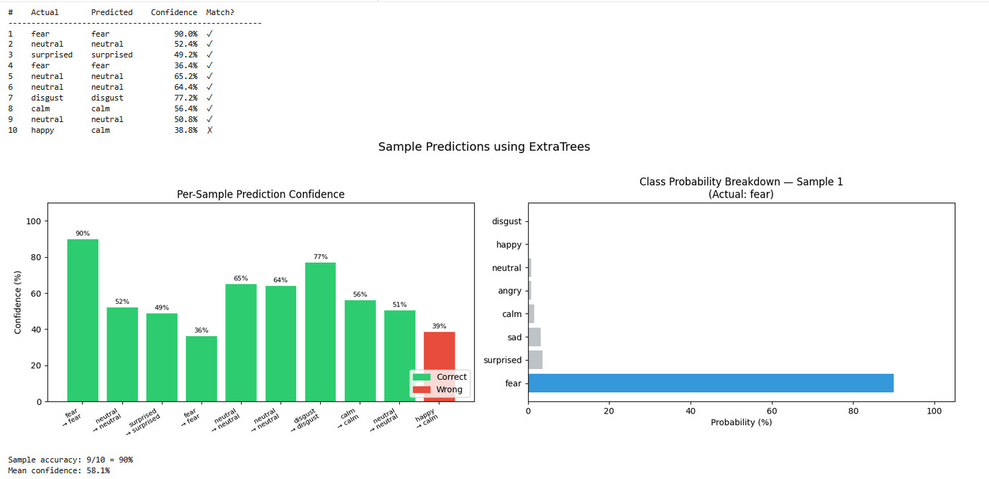
Figure 10 Sample predictions using ExtraTrees model with confidence scores and class probability distribution

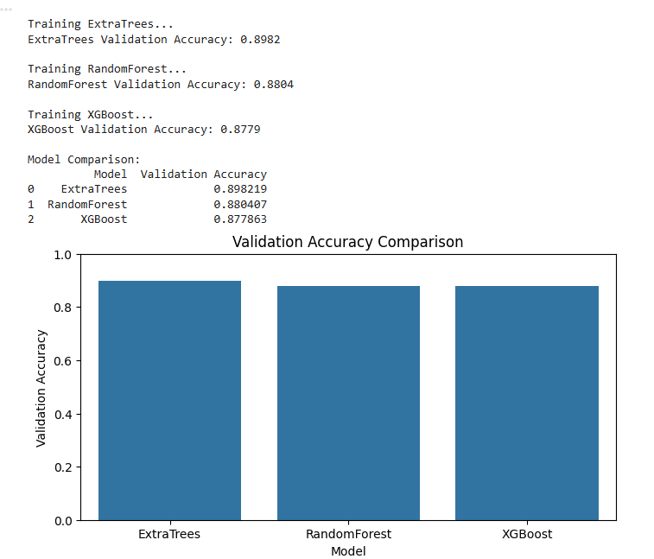
Figure 11 Validation accuracy comparison of machine learning models

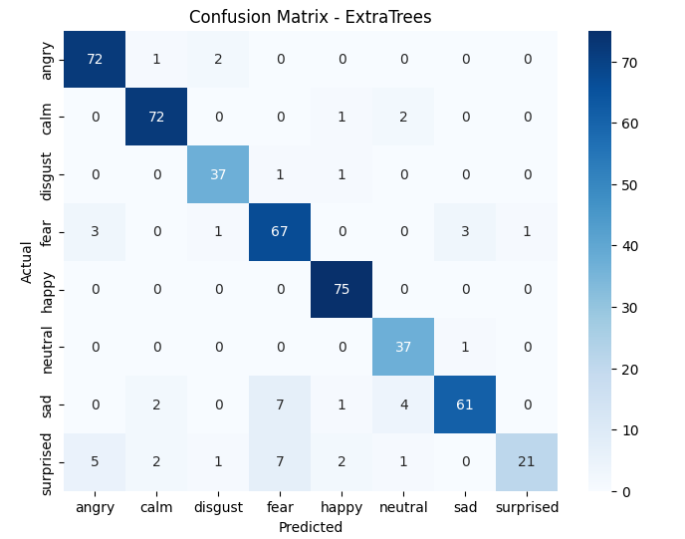
Figure 12 Top important features for facial emotion recognition

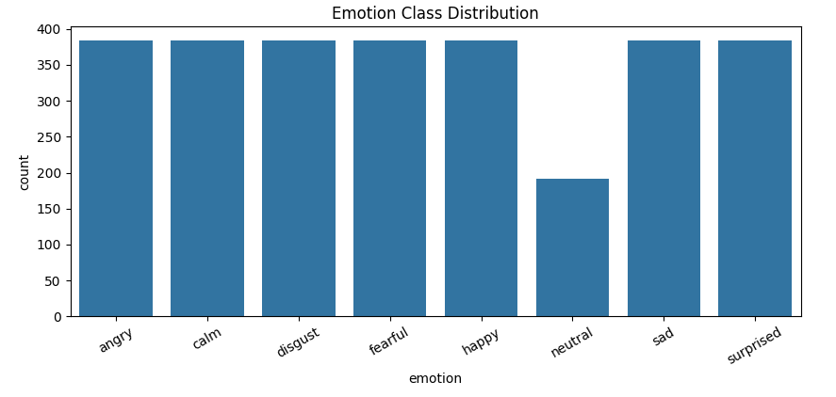
Figure 13 Emotion class distribution of speech dataset

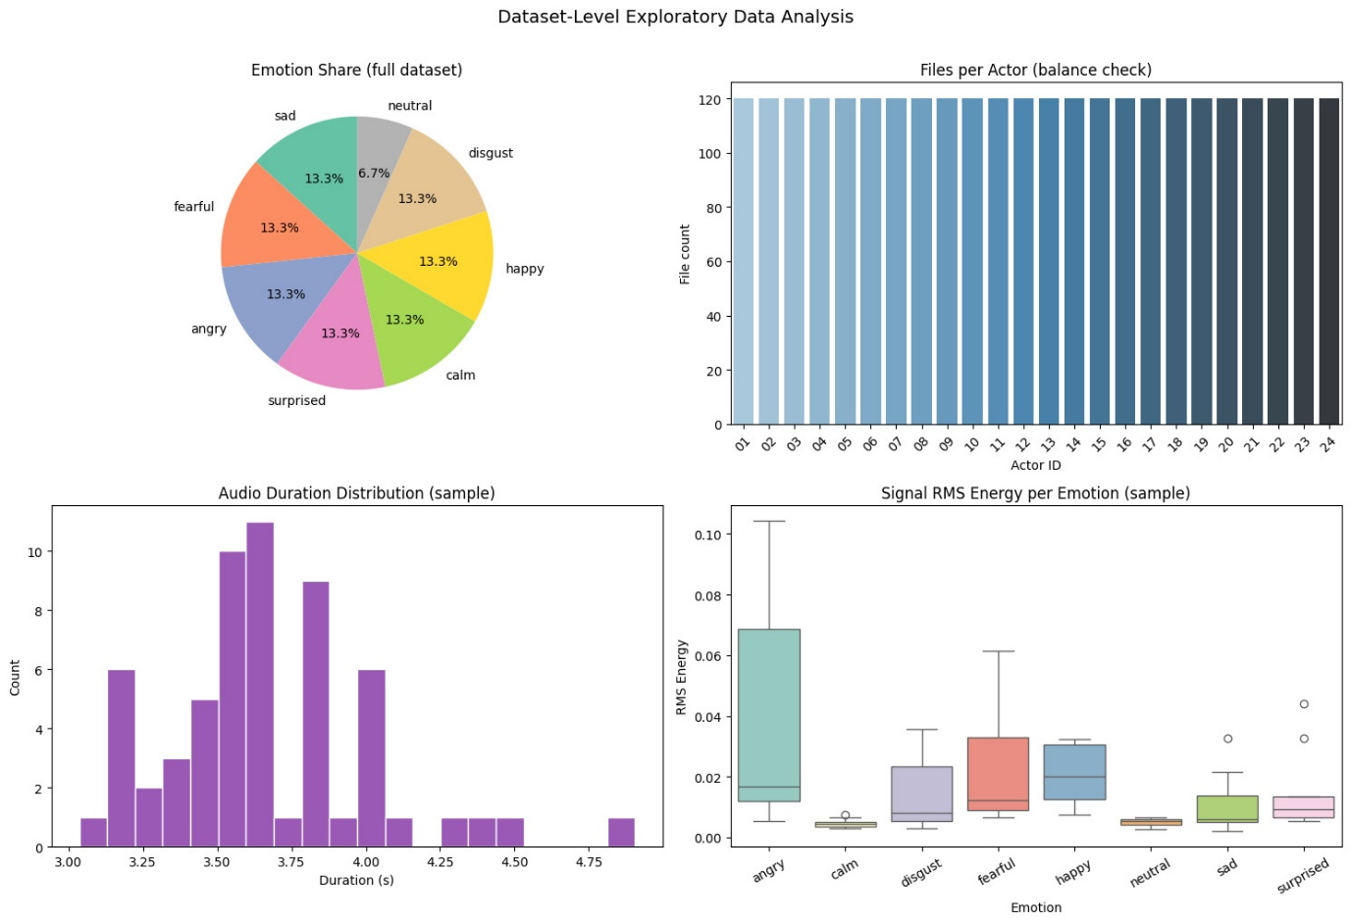
Figure 14Dataset-level analysis of speech data showing class distribution, actor balance, duration, and RMS energy

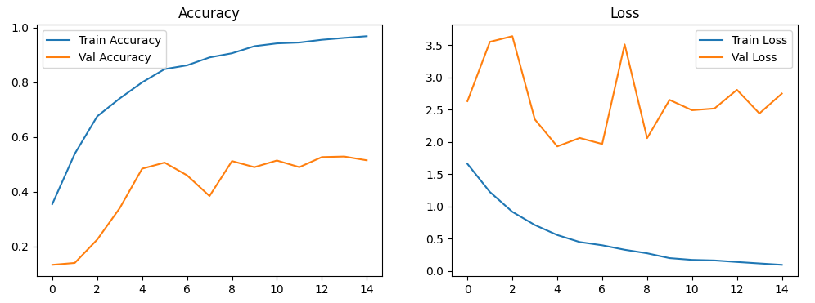
Figure 15 Training and validation accuracy and loss curves

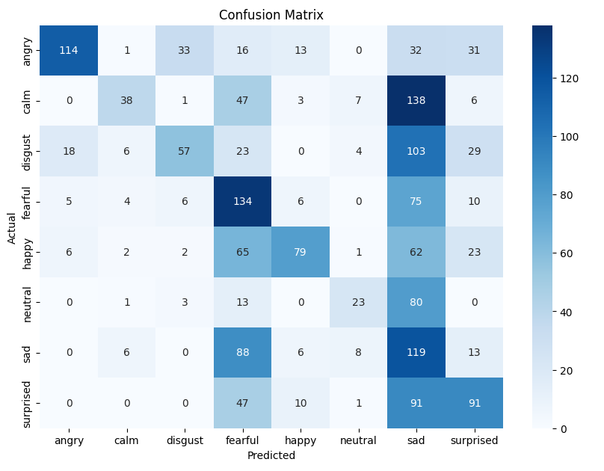
Figure 16 Confusion matrix of speech emotion recognition model
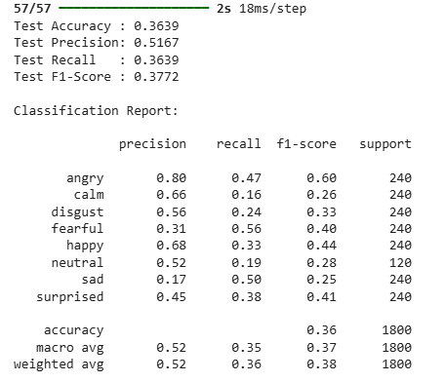
Figure 17 Classification report for speech emotion recognition model
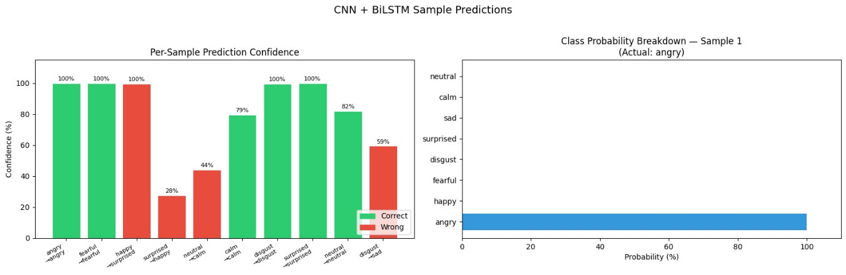
Figure 18 Sample predictions from CNN-BiLSTM model showing confidence scores and probability distribution
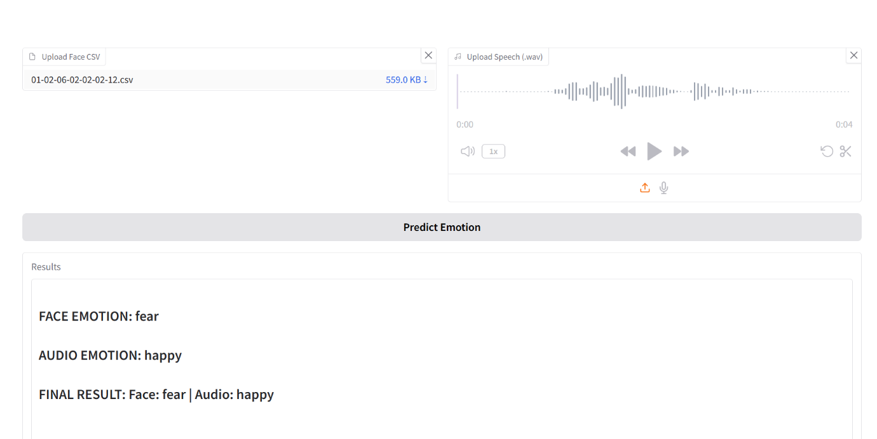
Figure 19 UI And Real time prediction
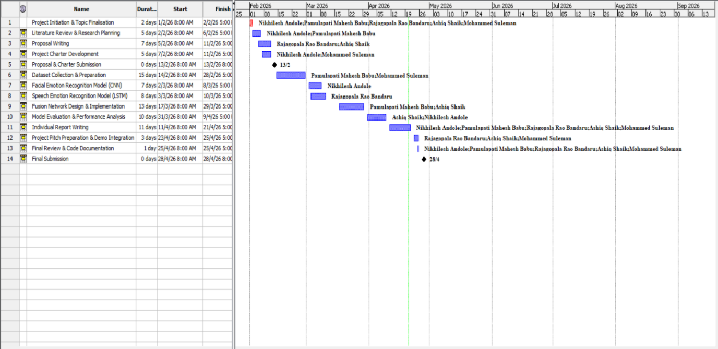
Figure 20 Project Timeline and Task Allocation (Gantt Chart)

